Ph.D. Thesis

Development and Evaluation of Mixed Reality Educational Applications

June, 2018

Graduate School of PaiChai University

Department of Game Multimedia Engineering

Xiaoyun Duan

Development and Evaluation of Mixed Reality Educational Applications

Supervisor: Soo Kyun Kim

June, 2018

Graduate School of PaiChai University

Department of Game Multimedia Engineering

Xiaoyun Duan

The undersigned have examined the dissertation entitle: "Development and Evaluation of Mixed Reality Educational Applications" presented by Xiaoyun Duan, a candidate for the degree of Ph.D. in Game Multimedia Engineering and hereby certify that in their judgment it is worthy of acceptance.

Advisor

June, 2018

__________________

Soo Kyun Kim Ph.D.

Professor

Dept. of Game Multimedia Engineering

Graduate School of PaiChai University

Principle Examiner

June, 2018

__________________

Sung Ohk Ahn Ph.D.

Professor

Dept. of Game Multimedia Engineering

Graduate School of PaiChai University

Examiner

June, 2018

__________________

Ph.D.

Professor

Examiner

June, 2018

__________________

Examiner

June, 2018

__________________

Development and Evaluation of Mixed Reality Educational Applications

XiaoYun Duan

*Department of Game Media Engineering*

*Graduate School of PaiChai University, Daejeon Korea*

(Supervised by Professor Soo Kyun Kim)

As the Chinese ancients saying goes for education: "Travel ten thousand miles is as important as to read ten thousand books. " One who wants to be successful, only study is not enough, study get wisdom and knowledge, travel get experience, experiences can transform into wisdom and knowledge. It may even be more practical and important than the wisdom gained from the book directly. However. The wisdom of the ancients warned us that in education, knowledge and experience are mutually reinforcing and indispensable. However, the reality is that because of the implementation conditions, the education we receive focuses on the reading of books, and the lack of sensory and intuitive stimuli to enable us to experience and understand the knowledge we have learned. Immersive experience is very important in education. However, under the traditional education mode, because of the limitation of time and space, it can’t provide sufficient experience environment for students. Such experience in the actual implementation of teaching is very inconvenient. However, with the rapid development of computer technology, the highly immersive gaming experience that appears in the movie “Ready player one” is likely to become a reality in the near future. In education, the reality of computer simulation can replace the function of “Travel ten thousand miles” and help us to make up for the vacancy. For example, when it comes to geography, with the use of devices the students are brought into the local terrain where there is the terrain is being learning. When explain biology, it is substituted into the local plant and animal life Environment, in the Chemistry class students can start experiments directly, etc. And more importantly, these implementations are not limited by space and time. with the support of devices, learners can experience anywhere and anytime. These technologies have brought a revolution to traditional education and brought untold potential to development.

A new era of education is approaching, allowing students to move from a passive acceptance process to an autonomous learning process. This will be driven by Virtual Reality and Augmented Reality. At present, there are many applications of virtual reality in many fields. This thesis designed and developed four Augmented Reality and Virtual Reality education applications cases, they are respectively: an Augmented Reality Ludo game; a VR Art Exhibition application; an Augmented Reality 3D Coloring game; and a MR (Mixed with Augmented Reality and Virtual Reality) Chemistry Lab, introduced each application design. Finally, through the actual experience of these applications, we analyzed the implementation results respectively in educational effect, user experience and devices, and get some experiences and methods of Augmented Reality and Virtual Reality education application design and development in educational field. This article analyzes the combination of Virtual Reality technology and experimental teaching, expounded the advantages compared to the traditional teaching model, introduces the basic principles of application design and interaction design, it provides a feasible way to improve the immersion of Virtual Reality education and improve the teaching process.

**Keywords:** Virtual & Augmented Reality; Educational Application; Experiential & Interactive Learning, Game-based Learning

# **Table of Contents**

Abstract i

Table of Contents ii

List of Figures iv

List of Table v

I. Introduction

1.1 Concepts

1.1.1 Virtual Reality 1

1.1.2 Augument Reality 1

1.1.3 Mixed Reality 1

1.2 Objectives and Scope 1

1.3 Contribution 1

1.4 Dissertation structure 1

II. Background 1

2.1 Researches 1

2.2 Educational Applications Typical types and Examples 1

2.3 Interaction Design 1

2.3.1 The development of human- centered Interaction Design 1

2.3.2 Interaction Design for VR and AR 1

2.3.3 User Interface Design for VR and AR 1

2.4 Summary 1

III. A Ludo game 1

3.1 Implementation Methods 1

3.2 Game Design 1

3.3 Project Implementation 1

3.4 Conclusion 1

IV. VR Art exhibition 1

4.1 Implementation Methods 1

4.2 Game Design 1

4.3 Project Implementation 1

4.4 Conclusion 1

V. AR 3D Coloring Game 1

5.1 Implementation Methods 1

5.2 Game Design 1

5.3 Project Implementation 1

5.4 Conclusion 1

VI. MR Chemistry Lab 1

6.1 Implementation Methods 1

6.2 Game Design 1

6.1 Project Implementation 1

6.2 Conclusion 1

VII. Evaluation 1

7.1 Evaluation system 1

7.2 Evaluations for the 4 cases 1

7.3 Evaluation Result 1

7.4 Summary 1

VIII. Conclusions 1

8.1 Review of Objectives 1

References 1

Korean abstract 1

Acknowledgement 1

# **List of Figures**

[Figure 1-1] 1

[Figure 1-2] 1

[Figure 2-1] T 1

[Figure 2-2] Cl 1

[Figure 2-3] H 1

[Figure 2-4] Ar 1

[Figure 2-5] T 1

[Figure 2-6] G 1

[Figure 3-1] 1**1**

[Figure 3-2] 1

[Figure 3-3] G 1

[Figure 3-4] 1

[Figure 3-5] s 1

[Figure 4-1] D 1

[Figure 4-2] C 1

[Figure 4-3] C 1

[Figure 4-4] 1

[Figure 4-5] Ti 1

[Figure 4-6] R 1

[Figure 4-7] A 1

[Figure 4-8] D 1k

# **List of Table**

[Table 1-1] H 1

[Table 2-2] F 1

[Table 3-3] Rd 1

Ⅰ Introduction

This chapter presents a brief overview of the context under which the research was conducted. Background information regarding this study is provided in order to establish research objectives and scope. Then, the contributions are discussed. Finally, the structure of the dissertation is outlined.

1.1 Concepts

Virtual Reality (VR) and Augmented Reality (AR) techniques were proposed as early as the 1960s. Earlier, they have been classified as the development phase of cutting-edge science. Mixed-Reality (MR) is based on the development of AR and VR proposed by Ronald Azuma, both VR, AR and MR are human interaction with the virtual environment generated by the computer interface, the prospects are very broad.

1.1.1 Virtual Reality

Virtual Reality is a simulation technology that emphasizes the hands-on experience and engagement of user simulation. Virtual Reality immerses a user in an imagined or replicated world (like video games, movies, or flight simulation) or simulates presence in the real world (like watching a sporting event live). Example of hardware players in VR are Oculus, Sony PlayStation and Samsung Gear VR [24]. The world of VR has always existed. Comic books, games, and novels are all traditional VR. However, they are limited to the visual and auditory experience, which are two of the five human senses, the new Virtual Reality have far more immersion sense.

The VR systems are divided into three types: VR HMD + PC; VR HMD + Mobile and VR all in one. VR HMD + PC representatives are: Oculus Rift, HTC Vive Fig.1 (a) HTC introduced Vive Pro and Vive wireless adapter. HMD + Mobile is represented by the Samsung Gear VR and Google Cardboard which is released at the Google I / O conference in June 2014, show in Fig.1 (b), in general, the HMD + Mobile is put the phone into the VR box using the phone screen as the VR display device. Although relatively rough experience, but such devices do not require complex electronic components, lower cost, and better mobility and portability. VR all in one machine as shown in Fig.1 (c) need to fully integrated display, computing, storage, power and other functional modules into the headset display device. If you want to achieve good performance, the display device is difficult to be lightweight and compact. 2017 Millet and Oculus jointly launched the VR Miracle VR machine: Mi VR Standalone.

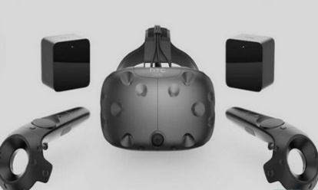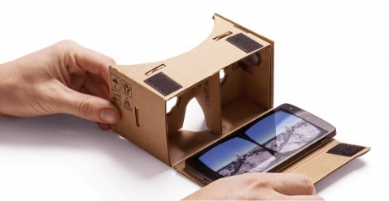 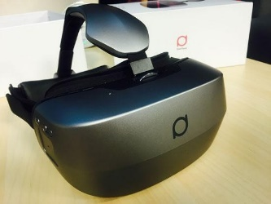

1. HTC HMD[1] (b) Google Cardbord[2] (c) Dapeng All in one device[3]

Figure1-1. 3 kinds of mainstream VR devices

The core technologies of VR are tracking and CG (computer graphics). In the latest technology of VR, the Google Tilt brush that won the Cannes International Creative Festival digital process awards can be represented. Tilt brush is Google's VR drawing software, using HTC VIVE HMD and control handles, which can make you in 3D Create paintings in space. Artists use digital technology to create in the three-dimensional world, not just the 2D plane. This will certainly affect the creation of the entire art field. This means that in the future you may be able to enjoy a painting as if you were admiring a building. As shown in Fig.2 (a) you can draw a volcano. It is envisaged that this technology will be used in the field of education. To give a small example, the math teacher in high school will do your best he can to help us understand that the graphic he draws on a flat blackboard as a solid figure, not a flat figure. Draw a solid directly in the three-dimensional world. As shown in Fig. 2 (b), the education process will be more intuitive.

 

(a) Draw a volcano in VR (b) Teaching math using VR

Figure 1-2. Google Tilt brush and Math application

Similarly, World Brush is an application that lets you draw 3D shapes and designs in the real world. It's very similar to Google's Tilt Brush. The cool part is that no matter what you draw, it stays there (or until you delete it), and you can smear it with an application brush around it, as a sticker or art painting. Each painting is anonymous and saved at the GPS location created. You can draw something and share it Online, so that other people can see and appreciate your work on the phone. Since World Brush is integrated with the real world and belongs to the definition of AR, we applications using AR below.

 

Figure1-3. World Brush

1.1.2 Augmented Reality

“Augmented” means improved or expanded or enhanced. Example of a general Augmented reality might be the ability to wear headphones that can allow you to hear sounds (higher or lower that the normal auditory spectrum) [7]. Augmented Reality overlays digital imagery onto the real world, Example of Hardware players on AR are Microsoft Hololens, Google Glass [24].

From its technical and implementation method, AR can be divided into two categories. One is Vision based AR, which is based on computer vision, and the other is LBS based AR. That is, based on geographical location information.

* **Vision based AR**

Computer vision-based AR is use the computer vision methods to establish the mapping relationship between the real world and the screen, so that the graphics or 3D model can be attached to the actual object that display on the screen, how to do this? Essentially, it is to find a plane of attachment in the real scene, then map the plane under this 3D scene onto our 2D screen, and then display the graphics or 3D model you want to show on this plane, from the technical implementation method it can be divided into 2 categories:

1. Marker-Based AR

This implementation method requires a pre-made marker (for example, a template card a certain shape or a QR code), and then places the Marker in reality, which determining a plane in a real scene, and then through the camera to recognition the marker and Pose Estimation, determine its location, and then the marker center as the origin of the coordinate system called Marker Coordinates, what we need to do is actually to get a transformation to establish a mapping relationship between the Marker Coordinates and the screen coordinate, according to this transformation can display the graphics or 3D model on the screen and achieve the effect of the graphics or 3D model attached to the real world marker. To understand the principle requires a little of 3D geometry projective knowledge. To transform from the Marker Coordinates to the screen coordinate, firstly, requires rotation and translation to the Camera Coordinates, and then from the Camera Coordinates to the screen coordinate. See below.



Figure 1-4. Marker-based AR

In the actual coding, all these transformations matrix. In the linear algebra, the matrix represents a transformation, and if the coordinates are left multiply by the matrix, it is a linear transformation. The formula is as follows:

The name of the matrix C is called the camera internal reference matrix, and the matrix Tm is called the camera external reference matrix, where the internal reference matrix is obtained by camera calibration in advance, and the external reference matrix is unknown, and need to estimate Tm according to the screen coordinates (xc, yc) , the Marker Coordinate that defined in advance, and internal parameter matrix, then display the graph or 3D model according to Tm. For example, when using OpenGL to display the graph, must loading Tm matrix under the GL_MODELVIEW mode.

1. Marker-Less AR

The basic principle is the same as that of Marker based AR, but it can use any object with sufficient feature points (for example, the cover of a book) as a reference plane without the need to create a special marker in advance and get rid of the binding of the marker to AR applications. Its principle is to extract feature points from template objects through a series of algorithms (such as SURF, ORB, FERN, etc.) and record or learn these feature points. When the camera scans the surrounding scenes, the feature points of the surrounding scenes are extracted and compared with the feature points of the recorded template objects. If the number of scanned feature points and template feature points exceeds a threshold, the template object is considered has been scanned, and then the coordinates of the corresponding feature points are used to estimate the Tm matrix, and then the graph is plotted according to Tm (similar to Marker-Based AR).

* **LBS-Based AR**

The basic principle is to obtain the geographical location of the user through GPS, and then obtain the POI (Point of interest) information of objects near the location (such as restaurants, banks, schools, etc.) from certain data sources (such as wiki, google, naver, baidu), and then through the mobile device electronic compass and acceleration sensor acquire the direction and tilt angle of the user's hand-held device, and according to the information establishes the reference plane (equivalent to the marker) of the target object in the real scene, and the principle of coordinate transformation and display are similar to the Marker-Based AR. This technology is implemented using the GPS and sensors, free from the reliance on Marker, the user experience is better than Marker-Based AR, and because it does not need to recognize the Marker and calculate the feature points, the performance is better than Marker-Based AR and Marker-Less AR, too. LBS-Based AR can be better applied to mobile devices than Marker-Based AR and Marker-Less AR.



1. QR code (b) Using Flat picture

Figure 1-5. QR Code and AR Application using Flat picture

At WWDC 2017, Apple brought AR Kit, a new Augmented Reality component for iOS 11 that works on iPhone and iPad platforms. AR Kit is Apple's augmented reality (AR) technology, delivers immersive, engaging experiences that seamlessly blend virtual objects with the real world. In AR apps, the device's camera presents a live, onscreen view of the physical world. Three-dimensional virtual objects are superimposed over this view, creating the illusion that they actually exist. The user can reorient their device to explore the objects from different angles and, if appropriate for the experience, interact with objects using gestures and movement [26]. The upper part of iPhoneX has a sensor that projects human invisible light to read the user's face 3D structure and instantly manipulate the data through the Apple Nerve engine to create a face model. This feature implements Face ID and cute Animoji show in Fig.9. The AR Kit uses the Visually Inertial Odometer (VIO) to track the surrounding environment with high accuracy and sense its movement within the room. For example, this application called AR ruler helps you to measure the precise size of an object without using any measurement tool. The AR Kit detects horizontal surfaces such as tables and floors, and tracks and places items at specific position. The AR Kit also uses camera sensors to estimate the amount of light available in the scene to apply the correct brightness to the virtual object.

Google also introduced Google Tango before it launched AR core in 2017. AR Core based on the original Tango made many improvements, such as real-time light rendering, the virtual object in reality looks more natural and true.

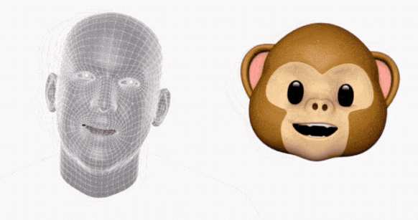

Figure1-6. iPhone X to include animoji, emojis animated based on your facial expressions [31]

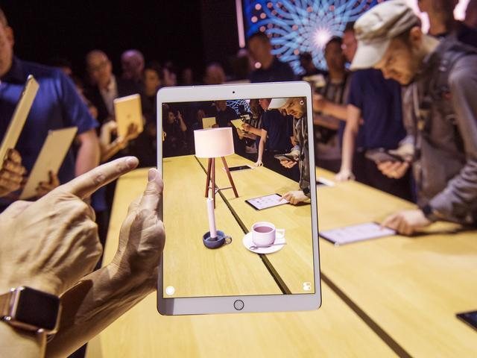

Figure1-7. Apple AR light projection

January 2015, Google launched Google Glass, 2016 Nintendo mobile AR game Pokmon Go swept the world, as shown in Fig.4, The user through the mobile phone camera in the real world to collect virtual animation characters. Augmented reality has also begun to open to ordinary users. On the entertainment side, AR camera application - FaceU, users can superimpose a variety of cartoon in their own photos in real time. On the military side, the concept of AR was first applied militarily and was first proposed by Thomas Caudell and David Mizell [27]. Its military application is also an important motivation for augmented reality. With AR technology, pilots can not bow their heads Look at the meter, you can read the HUD head-up display head-up display of the various states of the aircraft, such as heading, speed, fire control radar to provide enemy information. Similarly parking assist systems provide the system with the ability to proactively provide and make available information based on the current state of the vehicle (reverse gear) and relative position with surrounding obstacles without the user providing any additional information or instructions. Fig.2. At this year's CES showroom area, we saw Skully AR smart helmet, Civil Maps vehicle AR platform, and WayRay [25], which offers a solution for a car head-up display (HUD). Google Translate app uses your phone camera to translate textual information into another language and overlay display on the text.



Figure1-8. [Pokemon Go Scenes [12](http://link.zhihu.com/?target=https%3A//media.nngroup.com/media/editor/2016/09/18/pokemon-go-ar.jpg)]



Figure 1-9. The AR navigation system [30]

As another example, IKEA has a new application that helps you to truly see how each piece of IKEA products is placed in your own home or office through augmented reality (AR) technology. The app currently has more than 2000 IKEA product options.

 

Figure 1-10. IKEA Place application

In the latest AR applications, the vast majority of measurement applications. Among those applications the Measure Kit is different and more feature-rich. It can provide us with different functions and measurement methods. The application provides a track mode that allows the user to draw and measure trajectories. It can also be used to measure angles, person heights, build cube models, and more.

 

Figure1-11. AR Measure Kit Application

1.1.3 Mixed Reality

There are two explanations about MR: Mediated Reality and Mixed Reality.

Mediated Reality: Digital reality + virtual digital picture. Mediated Reality is an older tradition, introduced by Stratton before more than 100 years ago, and he presented two important ideas: constructing special eyeglasses to modify how he saw onto the world, ecologically motivated admission to conducting his experiments within the domain of his everyday personal life [8].

Mixed Reality : also known as naked eye reality + virtual screen, on behalf of the 2015 Microsoft released AR Hollerns AR equipment and Magic Leap in 2015, is the virtual environment projected into the real environment.

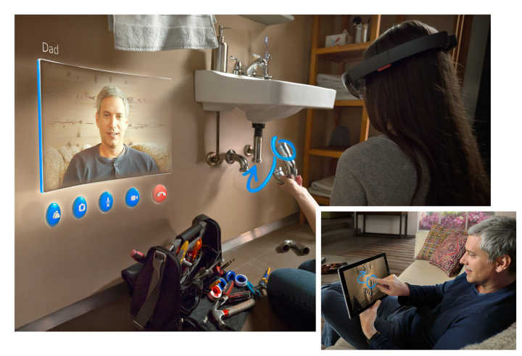

Figure 1-12. [HoloLens by Microoft](http://link.zhihu.com/?target=https%3A//media.nngroup.com/media/editor/2016/09/18/hololens.jpg)

Professor Ronald Azuma at the University of North Carolina University summarized the Augmented Reality into three parts: virtual-reality integration, real-time interaction and three-dimensional registration [3]. Paul Milgram and Fumio Kishino proposed the reality-virtual reality continuum, And the virtual environment as the two ends of the continuum, and the middle of them is called the "Mixed Reality" (Fig.12). Which is close to the real environment is to Augmented Reality, close to the virtual environment is to expand the virtual environment.

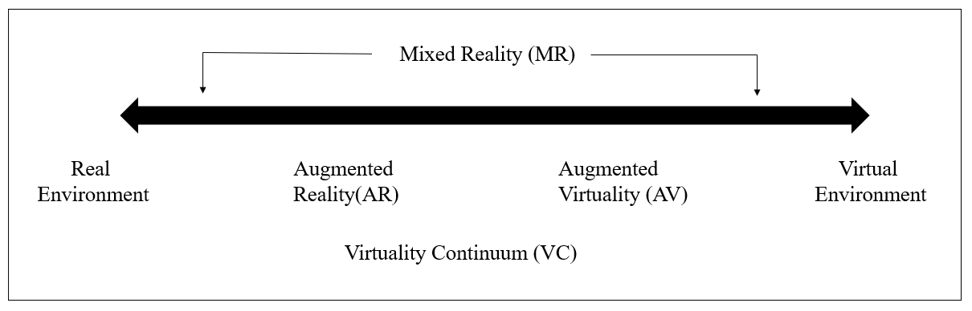

Figure1-13. Simplified representation of a “ virtuality continuum”



Figure1-14. Venn diagram of the focus of the work

The application fields of VR and AR are mainly in the fields of 1, Industrial manufacture and maintenance, displaying various auxiliary information to the user through the head mounted display (HMD), including the panel of the virtual instrument, the internal structure of the device, equipment parts map, etc. 2, Medical areas, using Virtual Reality help doctors diagnose the disease, treating the patients and training medical staff. 3, In the field of television broadcasting, the auxiliary information can be superimposed on the retransmission screen by the AR technology. 4, Entertainment, Games, VR Games, VR videos, movies and so on. 5, In the field of education, use VR for immersive teaching; 6, News report, through AR can make the text, pictures, to three-dimensional, increase reading interactivity and interest. 7, Tourism and exhibition areas. Through VR technology, we can create digital tourist attractions and exhibitions so that users can enjoy the beauty of the world without leaving their homes. The municipal construction plan uses AR technology to superimpose the planning effect on the real scene and obtain the planning results directly.

From the experience of the Last Jedi AR [40], a Google Pixel phone, to the impressive AR games presented at the Apple iPhone 8 conference, a variety of AR mobile applications can give us a highly immersive and realistic Augmented Reality experience. At the same time, Google Cardboard, such a simple VR device, priced at less than 20 dollars, significantly reducing the threshold of user experience Virtual Reality. In February last year, Cardboard completed two milestones: 10 million Cardboard shipments and 160 million app downloads. All of these changes make AR and VR appearing in our lives more and more frequent.

1.1.4 Distinguish and apply fields of VR，AR and MR

Virtual Reality, Augmented Reality and Mixed Reality, there are differences between the three technologies to achieve, simply put: VR puts the user into the virtual world, AR puts the virtual world in front of the user. The difference between VR, AR, and MR is illustrated by the image in Fig. 14: VR is to create a completely virtual world that separates you from the real world, Fig. 14 left. The core problem is graphic computing and immersion. AR technology is the put the virtual things superimposed on the top of the reality world, used to enhance and augment the information in the real world, as shown in Figure 14 middle. The core issue is image recognition and tracking. AR is the augmented reality of human perception. Google Maps, for example, is an AR application [4]. MR is generated based on the AR of the virtual information and the real world to maintain the natural adaptation and interaction, the virtual objects and real objects are recalculated, put them together, hard to distinguish each other, as shown in Figure 14 right, the robot was blocked part. The core issue is the 3D scanning of the real world, as well as the perception of distance. MR in this article simply refers to the combination of AR and VR functionality in the application.



Figure1-15. The distinguish of VR, AR and MR [33]

1.2 Objectives and Scope

If we make an overview of the research content of this thesis, systematically introduces the development and application status of Virtual Reality, Augmented Reality, and Mixed Reality technologies. The use of Virtual Reality and Augmented Reality can enrich the existing teaching resources and make the existing educational resources presented in a new form. The static resources became dynamic and multi- dimensional, which is good for the students to understand the learning, stimulate students’ interest in learning, improve the effectiveness of education and teaching. Virtual Reality and Augmented Reality have begun tentative applications in the fields of military, medical, commercial, education, maritime training and have achieved some success. The Objective of this work is to advance the educational effects towards AR and VR educational applications.

1.3 Contribution

This paper presents several cases of Augmented Reality and Virtual Reality applied to education. By applying to education and teaching, evaluate each application by scientific methods and obtain the evaluation of each educational effects. Through the analysis of the results Get the design and development points for such educational applications. This study aims to obtain the best educational effect of Virtual Reality applications in education. Here are four applications introduced.

1.3.1 A Simply Ludo Board game

AR is the integration of digital information with the user's environment in real time [32]. AR is developed based on VR, unlike Virtual Reality, which creates a totally artificial environment, Augmented Reality uses the existing environment and overlays new information on top of it. In this paper, I made a Ludo game that can allow multiplayers to play in a combination of realistic and virtual space. In this game, there are 3 characters with different colors and several buttons to control the characters, each character goes steps according to the random number on the screen.

1.3.2 A VR Art exhibition application

Virtual Reality (VR) is widely used in various fields, and it is expanding game and movie toward health care, business Software, education, and web services. Especially various researches are actively conducted in the field of exhibition, utilizing smart phone based detachable HMD (Head Mounted Display). The VR exhibition solves addresses both temporal and special constraints overcoming the unilateral information transfer exhibitions. This paper presents a method to overcome the limitation of time, space, and unidirectional information transfer in offline exhibition, and also presents a new method that utilizes multimedia visual design artwork as VR contents.

1.3.3 AR 3D Color game

The development from "Virtual Reality" to "Augmented Reality" realizes the combination of the real world and the virtual world. " The magical brush"[41] is no longer a legend. Augmented Reality technology is constantly being applied to all fields of society, changing the way of life and production, and the electronic books designed and developed by using this technology also bring challenges to traditional paper books. Based on the application of Augmented Reality technology and Augmented Reality technology in education, this paper takes "Color the Earth" 3D interactive mobile handset as an example, from the aspects of enhancing the characteristics of application, product design and technology realization A more detailed analysis, and design and development of the "Coloring XiXi" application. In order to provide reference for the development of Augmented Reality mobile applications.

1.3.4 MR Chemistry Lab

This paper is based on a research of the conventional chemistry experiment education limitations, design and developed a "Virtual Chemistry Lab" propose a new method of assisting present teaching aids. Compared with the traditional chemistry experiment teaching, the application can simulate the experimental steps repeatedly and ensure the realism of experimental results because of the high probability of danger and waste of reagents caused by students that unfamiliar with reagent, equipment and experiment steps. Reduce the probability of dangerous occurrence and effectively improve the efficiency of learning. There are two ways to implement the program, one is using Leap Motion as the interaction tool, another is by using Oculus HMD and Controller devices. And through analyzing different interaction methods in the VR system, find a better mode for this application. By evaluation, implementation of this application achieved the education objective more effectively.

1.4 Dissertation structure

There are four cases in this thesis that involved in VR and AR application in education. The study structure is as follow.

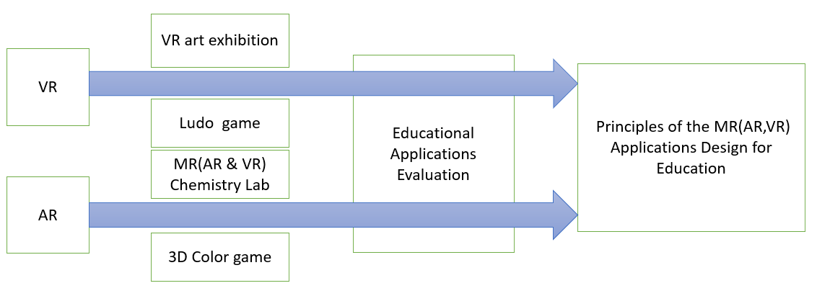

Figure1-16. Flowchart

Ⅱ Related Work

VR technology indeed has successful application cases in educational, here are some in the K12 classroom (K12 is the North American designation for primary and secondary education. The expression is a shortening of Kindergarten through 12th grade, the first and last grades of free education in the United States and English Canada). In China, more than 14 colleges and universities have their own VR Laboratory, many applications for Early Childhood Education were developed.

VR and AR are both technologies that can be used by college students' smartphones, and higher education institutions has seen AR and VR as the wave of instructional technology. Goldman Sachs predicts that by 2025, about $ 700 million will be spent on AR and VR application development in education, from mechanical operations to architectural design to medical surgery simulation. Market research firm Gartner predicts that by 2021, 60% of higher education institutions in the United States will use virtual reality technology in teaching.

2.1 Educational Applications types

Although VR and AR technology has not been applied in education for a long time, it is in accord with educational theory such as behaviorism and constructivism: 1. In behaviorism theory, learning is based on the connection between knowledge and the outside world to establish stimulus-response Link [18]. The learning environment created by VR and AR enables learners to be fed back while interacting with the environment and given the next action instructions so that the link between knowledge and response can be adequately built. 2. A large number of construction tools and performance areas provided by the VR and AR virtual learning situation, combined with the subjective initiative of learners, and Piaget's concept and practice of "moving labs to the classroom" and "learning is a real experience "Constructivism is consistent. Compared with virtual technology, AR can not only simulate the learning object in time, but also put it in a real environment and manipulate the model. Allow students to use a natural means of interaction for independent exploration and gain cognitive. Its advantage is the ability to present information that is difficult to express in a real world and seamlessly integrate that information with the real world so that learning interactions are as natural as interacting in the real world. This is very instructive for teaching abstract content and boosting learner interest.

The New Media Consortium, (NMC), a well-known organization in education, publishes a horizon report every year to introduce technologies that could have a significant impact on education. In the horizon report released in recent years, AR is listed as one of the six most promising technologies in coming years, and the words from "simple augmented reality" to "augmented reality" Changes can be seen this technology is rapidly becoming mature. It is noteworthy that this report put VR and AR in parallel in 2016, which shows that the two (VR and AR) technologies will be used together in education. VR and AR in education in the application of the following types:

2.1.1 3D virtual learning environment

The current development trend of three-dimensional virtual learning environment: First, the user involved in the creation, that is, create learning content entirely by the user. The second is to provide space for exploration and the 3d environment integrate with learning management system. Sloodle (Second Life Object-Oriented Distributed Learning Environment) [28] is a typical case, of course, it is still not perfect enough, need to have more research and practitioners’ efforts. Third, the virtual and real integration. The reality of the virtual environment depends on the development of graphics, but no matter how it develops, the virtual is virtual after all, and our learning activities are occurring in the real physical world, "Augmented Reality" enables learners to carry out a better experience when learning, and the technology should be more widely used in education. 4. Fourth，deep integration of 3D and AI technologies. Due to the complexity of learning, it is quite difficult for 3D virtual learning environment to be completely human-like, such as automatic answering, automatic making questions, automatic paper-marking and so on. It needs a breakthrough in AI technology.

2.1.2 AR book

One of the earliest examples of Augmented Reality in education was the Magic Book by Bellinghurst [14]. It is based on the book content into 3D scenes and animation, and the use of a special glasses to allow children to see the combination of the actual situation and the background, for example I dinosaur, show in figure. In this paper, I have designed and developed a coloring book, the book picture is painted, you can display a painted 3D model with a flatbed [22]. Using a mobile phone camera, a 3D model painted with colors can be displayed on the screen. The emergence of AR educational games matches the concept of edutainment, improving the students’ hands operate ability, see Chapter 6 for details.



Figure2-1. I Dinosaur [31]

2.1.3 AR Science teaching

Many scholars apply AR to science teaching so as to enhance learners' visual perception of real situations [19]. Clavula et al. [20] demonstrated an example of astronomy teaching in which teachers and students can explore the relationship between the Sun and Earth, day and night by rotating a virtual Earth. Cai Su and others [21] combined AR and Kinect somatosensory devices to visualize the magnetic field. When students learn about magnetic fields, they can interact with the device in real time through gestures to understand the distribution and changes in the magnetic field. Researchers at Vienna University of Science and Technology have done specialized mechanical teaching demonstrations [22]. Through physical experiments in the field of simulation physics of AR physics engine, the parameters of mass, force and path of motion are analyzed. However, the use of the system teaching need to configure the more expensive helmets, glasses and other equipment. Magnetic Field Visualization as shown in the figure below: Visualize the invisible magnetic field using the AR + Kinect somatosensory device and explore the interaction of the magnetic field under different conditions through natural interaction, with the magnet moving with the movement of both hands, the magnetic induction line constantly changing at the same time.

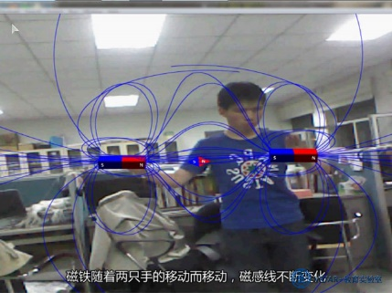

Figure 2- 2. Physical magnetic field visualization

The AR-based convex lens imaging experiment developed by Cai-Su team at Beijing Normal University explored the effect of AR technology on the effect of eighth-grade students' physics learning and deep-seated cognition [23]. The AR-based lenticular imaging aids simulate candles, lenticules, and fluorescent screens by using three different marking cards. When the camera captures a marker card, the 3D model of the lenticular lens with parameters such as the parallel axes used to mark the focal length and twice the focal length data will be displayed on the screen. The candle mark card and the screen mark card are respectively placed on both sides of the convex lens mark card. The screen will automatically present images based on the distance between the candle and the convex lens. If the distance between the candle and the convex lens is adjusted, the image on the screen will be displayed according to the convex lens Imaging rules change in real time. Suppose the object distance u, like 1u 1 + = v 1f distance v, the focal length f. According to the formula of the convex lens imaging, when u <f, it becomes a virtual image; when u = f, the screen does not appear an image; when u> f, the screen displays a real image. The experimental results show that AR has a greater impact on students who have lagged behind.

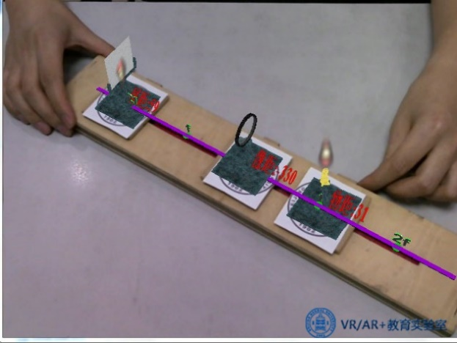

Figure 2-3 Simulated convex lens imaging[]

Research shows that AR tools can also help students remember the structure of atoms better. In traditional classrooms, the students’ understanding of knowledge and the persistence of memory are relatively low only through the teachers. However, teaching using AR applications can motivate students to become more focused. After visually seeing and interacting with the simulation model, students are more impressed with what they have learned. AR tools can improve students operate ability in experimental exploration. Compared to the keyboard, mouse, and computer operations, this method through AR technology is better for memorizing procedural knowledge. At the same time, the students also made some suggestions on this tool. For example, they hope that the simulation phenomenon of the material can be more realistic. In addition, some cartoons or animation elements can be added to make the software more interesting. In combination with PC or tablet teaching, AR technology is used with naturally interacting methods to control temperature, concentration, and catalyst conditions to explore how it affects chemical reactions.



Figure 2-4. Chemical hydrogen peroxide []

2.1.4 AR Language teaching

Use your tablet or phone to scan a card to recognize the word, then emerge the corresponding picture or 3D model and pronounce it, which is good for children to learn spelling and pronunciation of words. The study shows that this learning combines tactile, auditory and visual features, which can stimulate children's enthusiasm more easily than traditional teaching methods and has significant effect on learning words of non-native English learners. Using a cell phone to scan words, emerge matching pictures and pronunciation is also consistent with children's cognitive regular pattern, but the phone may distract children's attention. This type of teaching may be more suitable for one-on-one situations. The figure below is the word learning application called “Happy English”.



Figure 2-5. Happy to learn English interface

Chocolate company developed the VRCLASS chocolate interaction starting to develop a virtual reality immersive learning system from 2014, users can exposure to various scenes personally feel the charm of the future learning styles and interact with remote teachers interact; Teachers can fully develop the unlimited potential of virtual space and easily implement teaching methods that cannot be achieved in traditional classrooms. 50 minutes in a class and traditional teaching in the first 30 minutes. The teacher will recognize the spelling words with the students, such as giraffes, tigers, lions, etc. In the last 20 minutes, students will use VR HMD to enter the virtual world interaction, so that they can achieve consolidate the effect of learning. Parents also generally believe that this type of teaching is effective, as shown in Figure2-19.

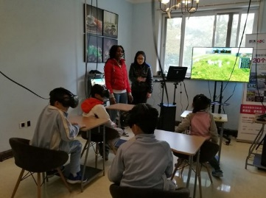

Figure 2-6. Cool fun ABC immersive children English learning [29]

2.1.5 Location Based AR Learning

During the use of this type of application, users can search for campus buildings based on the real scenes captured by the camera. After reaching the target building, the camera automatically recognizes the building information by capturing the image and presents it to the user as learning content. Most users mentioned that using mobile phones can access information anywhere and anytime, and the combination of positioning technology and augmented reality technology makes the search process and presentation more natural, eliminating the need for manual input. Most of the respondents mentioned the current waste of resources when using paper maps, and that the application is a better alternative to paper media; most of the respondents mentioned the way that the camera interacts with the real physical environment is interesting. Users also made a lot of constructive comments on the software, and some of the opinions were limited to the current hardware technology capabilities. For example, the slow speed of the campus wireless network caused the loading information to be too slow, the positioning time of the mobile phone GPS was too long and sometimes it was not accurate position and so on.

2.1.6 Other applications

Chin AR: Facilitating Chinese Guqin Learning through Interactive Projected Augmentation,Yingxue Zhang, Siqi Liu, Lu Tao, Chun Yu, Yuanchun Shi, Ying-Qing Xu, CCHI2015. Lower the threshold of Guqin learning, is conducive to the most ancient Chinese instrument to flourish. Guqin is good, but I learned from my classmates teaching Guqin at school that most people chose to give up after learning Guqin for only a month. Different from other musical instruments, Guqin has its own set of music system. The getting started requires learning and adaptation of many new concepts and methods. In this respect, the threshold of getting started is higher than that of other instruments. The essay, by enhancing learning techniques, gives beginners a lot of "hints," greatly reducing the threshold for beginners, and designed a complete set of interactive methods.



Figure 2-7. Chinese Guqin Learning Application

AR technology can superimpose the virtual information into the features of the real world, which can make the original boring knowledge in teaching into a vivid image, which can improve students' interest and enable them to learn better. Such as special geographical features, historical events, and things that are not easily accessible can be presented to students through AR technology. From the application examples of VR and AR introduced in the previous section, and the Pokemon Go, an AR game that has been popular around the world for a while, we can see that AR is more easily commercialized than VR.

2.2 Interaction Design

2.2.1 The develop of HCI

HCI (Human Computer Interaction) refers to the exchange of information between a person and a computer, including a computer providing information to people through an output or display device, and a person entering information into the computer through an input device. The purpose of human-computer interaction is to discuss how to make the computer designed to help people to be more safe and reliable, more efficient to complete the task to be completed. Mainly experienced in three stages.

1, Multi-language User Interface

Inefficiency. HCI began with the emergence of the world's first computer ENIAC, the operating system is by the way to give orders to the computer, language barriers give a strong professional sense. The users need to master a computer language proficiency, otherwise the interaction process is inefficient.

2, Image User Interface

Operational, graphical user interface is the mainstream of the current user interface, represented by the Microsoft, which fundamentally changed the situation in the past to remember a large number of orders. A common feature of current GUIs is that they convey and display information through windows. In addition, they are operated by using keyboards and mice. Because image-based user interfaces rely heavily on visual recognition and manual control, so this interface is easy to operate.

3, Multimedia User Interface

Multimedia technology is a transitional technology before the emergence of naturalized interactive technology. Before the advent of the multimedia user interface, the user interface design had completed the transition from language to graphics. However, with the development of multimedia technology, the introduction of animations, audio and video media, especially the audio media, has greatly enriched the computer's expression of information to serve people better. Greatly improving the efficiency of HCI. The main advantage of the multimedia user interface in HCI is that it can improve people's recognition of information and its choice.

With the further development of computer technology, new forms of interactive technologies and user interfaces have emerged, such as voice recognition, gloves and other sensors, gesture recognition, handle operation, eye tracking, and so on.

2.2.2 Interaction Design for VR and AR

Since 2014, the advent of virtual reality entertainment devices such as Oculus, Gear VR and HTC Vive has enabled VR technology to serve ordinary consumers, users entry a new era of human-computer interaction. The user is no longer an isolated individual but a virtual Part of the environment, establish a natural link between people and machines [10].

VR interacts in various ways, but in terms of current interactions, it is in the form of a handle, tactile feedback. At present, VR has the following interaction modes: **Gesture tracking**, the use of gesture tracking as an interaction can be divided into two ways: The first is the use of optical tracking, such as depth sensors such as Leap Motion and Nimble VR, and the second is the use of data gloves on the sensor. Microsoft HoloLens is an AR hardware that uses gestures to interact. When wearing HoloLens glasses, you can control the virtual object and function menu interface by pointing, dragging, and stretching in the air. For example, use the Air tap gesture to open the hologram and use Bloom gestures to open the start menu. **Full-body motion capture**, which is not necessary in many situations. Besides, the problem if this mode is that there is no feedback. It is difficult for users to feel that their motions are effective. **Tactile feedback**, the Virtual Reality controller mainly refers to the button and vibration feedback. At present, the three VR head-display manufacturers Oculus, Sony, and HTC Vive all adopt the virtual reality controller as the standard interactive mode: two-handed separation, six-DOF space tracking (3 rotational degrees of freedom and 3 translational degrees of freedom), using handles with buttons and vibration feedback can implement most of the interactions. **Eye tracking**, the founder of Oculus, Palmer Rudge, once called it “the core of VR” because it detects the position of the human eyes, providing the best 3D effect for the current viewing angle, and making the images that VR HMD display will be more natural, shorten the delay and the increased playability greatly. Eye tracking technology is considered by many VR practitioners to be a technological breakthrough in solving the problem of virtual reality vertigo. Japanese VR HMD - FOVE has incorporated primary eye tracking technology. **Voice interaction,** Gesture control has a fatal flaw. It is that raising his hand frequently will cause the arm to be sore. Now Microsoft Cortana, Google Now, Apple Siri, and Amazon Echo are all excellent speech recognition assistants, but they can only be used as auxiliary tools. Using voice control, the user does not interfere with the VR world he is observing. The way interaction with the VR world is more natural, and users do not need to move their heads and look for UI or other items, and they can communicate anywhere in any direction. **Sensor**, Sensors can help people interact naturally with multidimensional VR environments. For example, all directions treadmills, Virtuix, Cyberith and domestic KAT are developing such products. Also, the full-body VR suit which is called “Teslasuit”, wearing this equipment, you can feel the changes in the Virtual Reality environment, such as users can feel the breeze blowing, and feel the shot in the shooting game. These are generated by various sensors on the device, such as smart inductive rings, temperature sensors, light sensors, pressure sensors, visual sensors, etc., which can make the skin produce a corresponding feeling through pulsed current, or touch and sense of smell in the game. **Virtual Reality Theme Park**, “The Void” for example, uses this approach. It builds the virtual world on top of the physical world, allowing users to feel the surrounding objects and use real-world props, such as portable lights, swords, guns, etc.

The input mode of VR interaction has not been unified, and various interaction devices in VR still have their own deficiencies.

2.2.3 User Interface Design for VR and AR

The flat interface design can be used in the AR and VR interface. The design of the GUI must focus on how to present information and facilitate browsing and interaction better. Then the advantages of Flat Design are manifested as follows: 1. Better presentation of content and data, avoiding too much visual elements to interfere with information identification; 2. Applicable to the effects of transparency, allowing users to observe the external environment. Take the Google tilt brush example, shown as the Figure below. This is the Color Picker which is provided, which is similar to what we usually use in windows or desktop (flat style), rather than giving you some boxes of "pigment" to color.



Figure 2-8. Flat Design User interface in Google tilt brush

Ⅳ. VR Art Exhibition

The virtual art exhibition application can allow users to appreciate art works at any time without leaving home, which breaks the time and space constraints.

4.1 Game Design

Virtual Reality (VR) is widely used in various fields, and it is expanding game movie towards health care, business software, education and web service. Especially various researches are being conducted in the field of exhibition, and methods for implementing Attachable-removable HMD (Head Mounted Display) VR contents using a smart phone are being presented. The VR technology in the field of exhibition solves both the time, space constraints and the unilateral information transfer to the exhibitions displayed in the offline exhibition. The advantage has that this can overcome the quantity, time and the geographical constraints that should be met by direct visits. This paper presents a method to overcome the limitation of time, space, unidirectional information in offline exhibition, and also presents a new method that utilize multimedia visual design works as VR contents.

Among the Mobile +VR devices, the Samsung Gear VR indeed has better leak-proofness, but you must have one of the latest Samsung phones such as the Galaxy S6, Galaxy S6 edge, Galaxy Note4, Galaxy Note5, and Galaxy S6 edge+. So that Google Cardboard is a good choice as a VR entry-level experience, mainly because the cost is relatively cheap and most people are able to afford it. Besides, Android and IOS most mobile phones can be supported. In the Google Cardboard introduction page, there is such a sentence "Experience virtual reality in a simple, fun, and affordable way" summed up Google Cardboard has the following advantages compared to other mobile VR products: 1, cheap, 2, easy to carry, 3, while supporting both Android and IOS phones with appropriate screen size. Therefore, this game we have selected Google Cardboard as a game device. According to the guideline, users can personally make a Cardboard.



Figure 4-1. Cardboard

This application is a multimedia mobile visual VR application using Google Cardboard's multimedia visual design. Users can experience the virtual art exhibition from the first-person view. Because the supported interaction ways between Google Cardboard and mobile phones are very simple, we have used users’ gaze to control the direction the user want to move toward. After the application starts, the character moves in the direction of the user's gazing direction and stops when it enters a certain distance in front of the painting or the obstacle. The user can view the painting and continue to move when the gazing direction changes.

4.1.1 Composition of contents

Different from the actual exhibition halls, the most important thing is to ensure the distortion of the visual contents of Virtual Reality are minimized, so that improve the users’ subjective initiative and immersive sense. It is also important to decorate the display environment. The digital exhibition works was obtained by the basic offline exhibitions. There are totally of seven electronic works in this application. Figure 4-1 are 3 of them.

  

Figure 4-2. Work of Arts

4.1.2 Immersion for VR exhibition

In this section, we explain various analytical methods to increase the immersive and experiential factors by moving multimedia visual design contents that presented in offline exhibition to virtual reality. The HMD devices basically has a characteristic that provides experience and immersion. However, when the offline content is changed to digital content, it is assumed that the problem raised in the previous [] is a problem to be solved in this paper. Focusing on enhancing immersion and experiential factors through solving these problems. In particular, [] defines the disturbing elements as follows. "It was pointed out that if the display image size was small, and the stereoscopic effect was small, the motion was not reflected properly, cannot obtain a complete immersion."

On the experiential side, the obstacle to HMD immersion is "I can move freely, but the result of the movement cannot be visually reproduced similar to reality". Based on the problems raised above. As shown in Table 1, we suggest solutions for enhancing experiential factors and immersion.

Table 1: Influencing Factors of Sense of Experience and Immersion in Virtual Reality Display

|  |  |
| --- | --- |
| Division | Experience and immersion factors |
| Display panel Performance | Contrast ratio, color recall, color depth, color temperature, Gamma curve, Luminance |
| Image Resolution | Difference in image resolution. |
| Image Size | Difference in image size when using HMD device. |
| Exhibition layout | Shading and shadow effects |

The element that can enhance the immersion feeling [] to show the intention of the artist in the exhibition works can be judged to be the degree of experience that stimulates the temporal dissociation, elevated enjoyment, and curiosity. In exhibition works, such factors as color and layout can be considered according to the artist's intention, but it is difficult to apply it to the overall work. For this purpose, the proposed method in Table 1, that through create an exhibition environment, active experience of multimedia visual contents can be enhanced as an experiential factor. **~~~?~~**

4.1.3 Interaction Design and Operating Mode

In terms of user interaction, in order to use Google Cardboard as a tool to implement multimedia exhibits, the interaction mode is particularly important, especially if you want to approach the actual exhibition, the interaction mode must follow the natural interaction as much as possible, through analysis of the hardware conditions of Google Cardboard, Using the way of the user's FPV to interact, the user in the virtual world automatically advances toward the direction, and stops when entering a certain range near the art works or obstacles. At this time, the user may stop to view the painting or walk away by change the direction of view to change the direction of movement.

4.2 Implementation

This application uses Unity 3D 5.1 as a development tool. Unity has built-in support for virtual reality from 5.1. Download CardboardSdkForUnity. Packadge and import it into Unity project. In the hierarchy panel, use Cardboard Main Prefab instead of standard camera, check the Virtual Reality Supported option in project setting, and then the game can be switched to VR mode preview.

The following is the main code for the user to move and determine the obstacle part:

float walk_speed = 2;

void Update() {

Ray ray= new Ray(); // Create ray

RaycastHit hit; // Collision

if (Raycast) //Collision check

{

Transform.translate(forward, walk_speed); // forwarding

float distance = vector3(position.hit, position); // calculate distance

if (distance < 3) // check distance to wall walk

{ _speed = 0 ; }

else { walk_speed =1; }

}

}

The application development environment is Windows 10 64bit, Unity3D 5.1, and the development language is C#. The hardware devices are Google Cardboard and Samsung S4 smart phones. The following figure shows the program execution scenes and various visual design contents in a virtual environment. The effect and experience are not inferior to those in the real world exhibition hall.



(a)



(b)

Figure 4-2. Game Scnens

4.3 Conclusion

Nowadays, smart phones have been popularized and become our daily necessities., various applications can be easily used through smart phones. Translate it to VR mode by using Google Cardboard also give users a better experience. For those who are keen on appreciation of art exhibition can visit art exhibition anytime and anywhere. This study analyzes the factors that affect user experience and immersive in this trend and proposes ways to improve user experience and immersion based on existing conditions. The virtual art exhibition application can allow users to appreciate art works at any time without leaving home, which breaks the time and space constraints.

Ⅴ. AR 3D Coloring game

At present, Augmented Reality technology has begun trial application in military, medical, commercial, education, and maritime training which achieved certain results. The combination of education and AR technology brings about innovative development in education [5]. At present, the application of AR technology in the field of education is mainly applied in the following aspects: AR-based classroom teaching; AR-based skills training; AR-based mobile learning.

Through the development of this AR-based mobile learning game which is called “AR TuTuLe”, the flat object can be “moved on the paper” by a portable mobile device scanning. The multiple forms of interaction stimulate the interest of the learners and enable them to interact with the 3D “partners”. Learn knowledge and understand the world. Break through the limitations of the paper book, promote the acquisition and absorption of knowledge, improve the interactive effect of teaching, and fit in with the concept of entertaining, improve the students' ability to operate, recognize, the ability of literacy and identify colors. In the future, through further improvement, with the advancement of smart classrooms and digital learning, Augmented Reality e-books as emerging learning media will have a great impact on classroom environment, education model.

5.1 Game Design

AR technology is a combination of virtual image and reality. Interaction should be the main focus of AR. However, due to the fact that smart glasses are not yet formally cameintothemarket, AR technology still stays on the screen of mobile devices. This results in many AR technologies actually as a kind of gimmick, at present, AR applications still focus on acceptance visual experience, coloring AR products are a successful product that bring a good interaction to the AR application. It has the following characteristics: high interactivity and entertainment; it can be designed independently or as a part of other applications, less investment than traditional games; need collaboration between different areas, requires a higher calculation mapping UV matching, the main feature of the 3D coloring game named “AR TuTuLe” is ​​that the models and animations are interactive. Expression of color rendering in AR has two ways of: one is real-time rendering model texture content; another is rendering model texture content only once after receipt of order.

In this section, according to the technologies and methods of AR painting application development, a fun cartoon character painting and dressing application suitable for pre-school young children was developed. This application can be run on the mobile device with simple operation and portable. Users need a few pieces of paper or cards to enjoy it anytime, anywhere. The design motivation of this application is to help children recognize colors and express their desired combinations through coloring and collage. children can also observe their designs and collocations from a 3D and 360degree angles.

This game consists of two parts: AR and AR+ as shown in Figure 5-1, which is the main scene of the game.

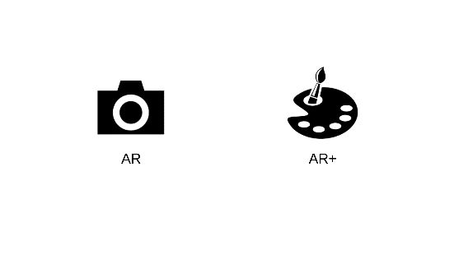

Figure 5-1. Start Scene

Two characters correspond to two recognition maps, and the model of each character is not static, when the 3D rendering has a simple dynamic effect, when the user covers the original picture with a piece of paper with a different color, the character will also change its color in three dimensions immediately. The following figure5-2 are the scenes of each one of the characters when running. The steps for using this application are as follows shows in figure5-3: (a) Coloring the A colorless sketch picture that was pre-printed; (b) Running the game with a mobile device, aiming at the picture, and displaying a 3D dynamic model at the top of the paper; (c) Using other colored pieces replace the corresponding parts of the recognition picture; (d) The 3D model that has changed color is displayed on the top of the paper.

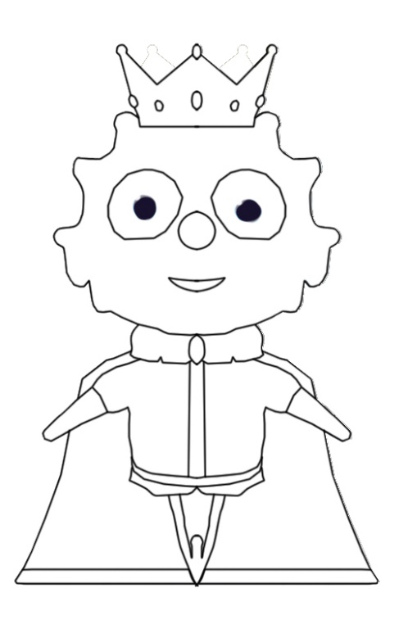 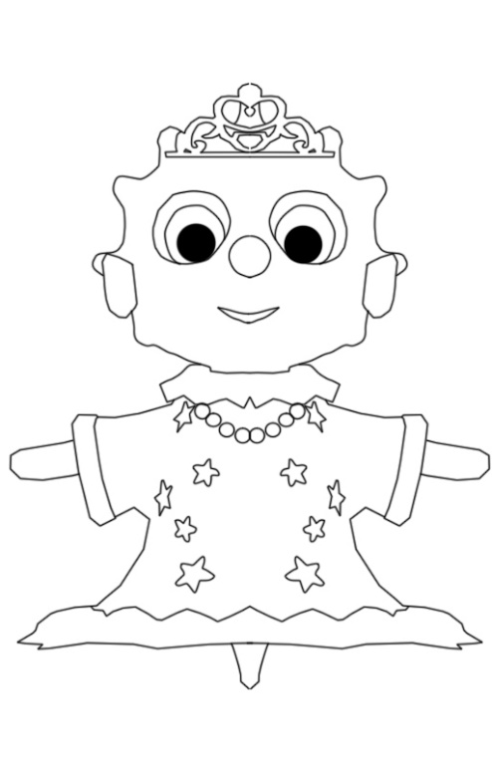

Figure 5-2. Two characters’ original sketch

  

(a) (b) (c)

Figure 5-3. The AR Scene (a) (b); the AR+ Scene (c)

5.2 Implementation

The implement steps of this application are as the figure bellow.



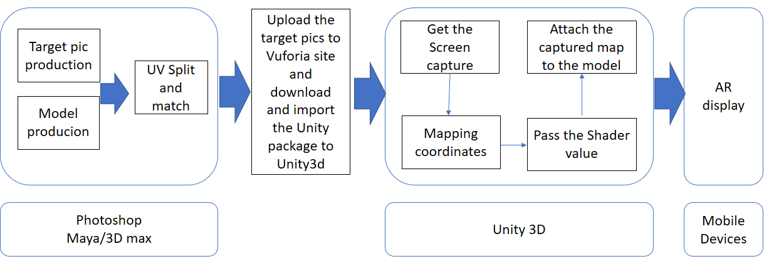

Figure 5-4. Application Development Steps

Get the world coordinates of the four points on the screen and save them in four variables

halfSize = new Vector2(gameObject.GetComponent<MeshFilter>().mesh.bounds.size.x,

gameObject.GetComponent<MeshFilter>().mesh.bounds.size.z) * 50.0f*0.5f;

targetAnglePoint1 = transform.parent.position + new Vector3(-halfSize.x, 0, halfSize.y);

targetAnglePoint2 = transform.parent.position + new Vector3(-halfSize.x, 0, -halfSize.y);

targetAnglePoint3 = transform.parent.position + new Vector3(halfSize.x, 0, halfSize.y);

targetAnglePoint4 = transform.parent.position + new Vector3(halfSize.x, 0, -halfSize.y);

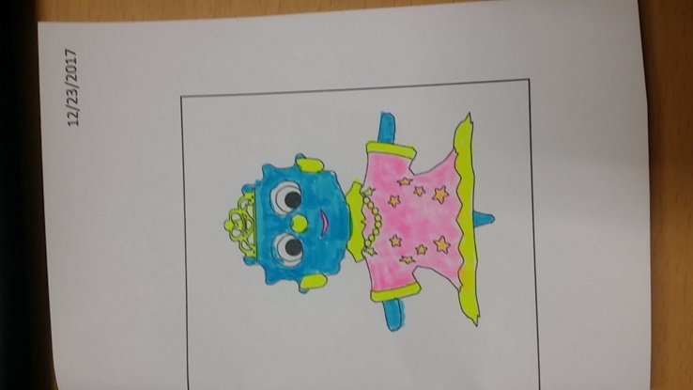 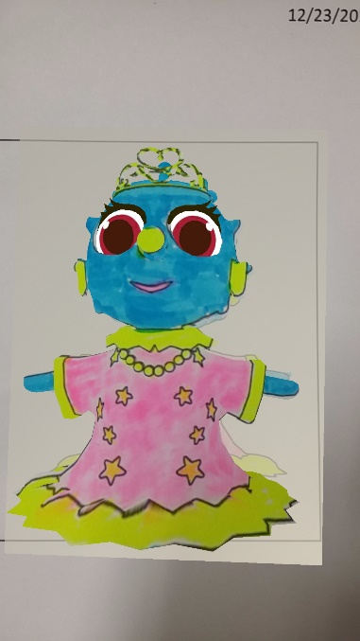 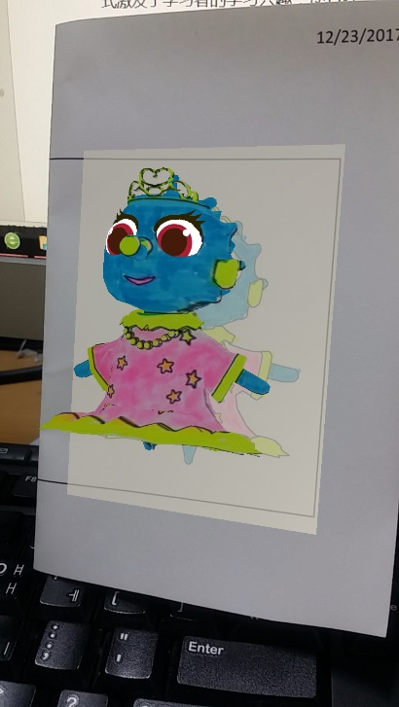

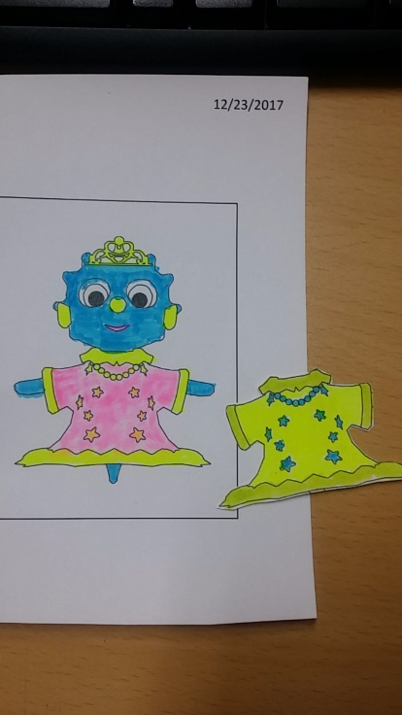 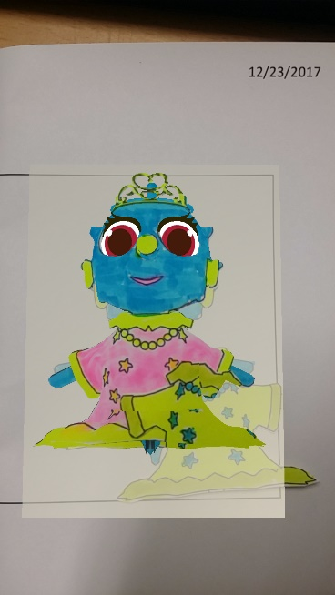 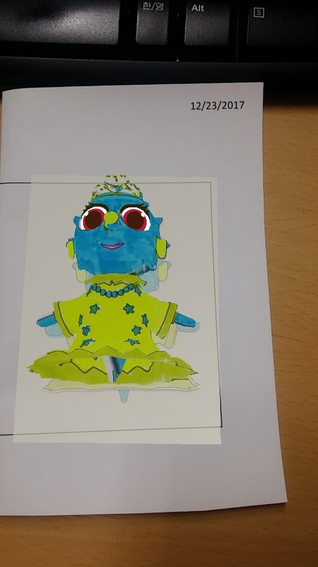

Figure 5-4. Corloring XiXi papers

5.3 Conclusion

The application of augmented reality technology in education has provided new ideas for teaching and learning. As a representative product, AR 3D e-book breaks through the limitations of paper books, provides learners with realistic and intuitive learning materials, and promotes knowledge. Get and absorb. allows the planarized object to "move on a piece of paper" through a simple and convenient scan of the mobile terminal. The interactive form stimulates the learner's interest in learning and enables them to learn knowledge and understand the world in communicating with the concept of three-dimensionality. Of course, AR 3D e-books are in the development stage. Whether it is the fidelity or interactive effect of 3D models, there are deficiencies, which need to be further improved in the later research and production. With the advancement of smart classrooms and digital learning, AR 3D e-books, as emerging learning media, will have a disruptive impact on the classroom environment, teaching model, and even education.

Ⅵ MR Chemistry Lab

Through virtual chemical experiment equipment, students can perform simulation experiments in a high immersive environment, familiarize themselves with experimental procedures, observe and record experimental phenomena, save reagents, reduce danger, and achieve the goal of learning at any time.

The conventional education system modes are primarily passive or receptive learning style, many teachers think that students learned the experimental principle and method is important and enough, so they no need to do many experiments, according to our research, present teaching methods have limits shows as below: First: Lack of motivation and of activity, students are shown the experiments results instead of probing the results. Second: Temporal and spatial constraints; students cannot do the experiments anytime and anywhere for the limits of objective conditions and cannot repeat the experiment steps. Third: Wasted reagents and danger, some of the reagents are dangerous, therefore many practices are requisite before using the real ones. In this way can save the reagents and lessen the danger. To break the limits as we build up this application, use this can let the users practice the experiments wherever and whenever they need in a more active and probing learning way, and can also can save the reagents and lessen the danger probability. Meanwhile compare to the general 2D chemistry applications it guarantees the immersion almost alike the real world, in addition we also design a feature that users can see the microcosmic things like molecular structure using mark AR. All the solutions are confirmed Improved learning efficiency.

Chemistry VR Lab is an educational experience that can virtually simulate lab procedures and important lab safety measures. The user is immediately immersed inside a Virtual Reality laboratory, and can begin walking around using the Oculus HMD to interact with the environment. There are lab procedures and safety guides spread across the tables, and a great deal of lab equipment that can be picked up, placed, thrown, or actually used in real lab procedures.

The first step is to actually put on your Oculus HMD and hold the handle Controllers on your hands. After that, it's free reign over lab experiments. For example, it's completely possible for the user to grab a paper that show the introduction on it or a match, and then place the match stand on the jiujingdeng burner, the jiujingdeng will get borned, place the meitiao on the fire,….

6.1 Game Design

The chemical knowledge involved in this application is a simple chemical experiment. Observe that one substance can produce other substances through chemical experiments. Through this experiment, we first understand what chemical experiments are. The experimental phenomenon: intense burning, emitting dazzling light, taking a lot of white smoke, generate white solids. The effect of the dazzling white light emitted when the magnesium bar burned was achieved by a particle system. The burned magnesium bar was placed in a beaker containing acetic acid. The magnesium bar was gradually dissolved without bubbles; the unburnt magnesium bar was put in the same package. In beakers with acetic acid, magnesium strips were observed to gradually dissolve, and bubbles were generated in the beaker.

The experimental principles and reaction equations involved are as follows: The combustion reaction of the magnesium strip changes the arrangement of the atoms.

2Mg+O2——ignite——2MgO

Mg + 2CH3COOH ——(CH3COO)2Mg + H2（ ↑ ）

2CH3COOH+MgO=(CH3COO)2Mg+H2O

(intro)

According to the education content described above, two implementation methods are adopted: Mobile + PC + Leap Motion and PC + Oculus HMD. When running on Android phones, you need to use Leap Motion's gesture recognition to interact and implement the experiment process. However, since Leap Motion doesn't yet support running directly on the phone, we use Unity 3d Engine + Remote, which is the Unity Remote function that runs on Unity in the PC and is displayed on the phone screen. In order to achieve the combination of virtual reality and Leap Motion. it is divided into AR part and VR part, VR part is virtual chemistry experiment, and there are three experiments designed. Due to the model and some experimental effects, we only test the first experiment, which is the “burning of magnesium bar” experiment. In the AR section, the atomic card is scanned to show the model diagram inside the atom. Under the condition of PC and Oculus, the experiment was performed through the Oculus handle Controllers, and the virtual reality screen was displayed through the HMD. The detailed design are as follows.

6.1.1 Leap Motion



Figure 6-1. The Design Flowchart

The program has three scenes, Main scene, Virtual Reality scene and Augmented Reality scene. Experiments are carried out in a virtual reality scene. In Experiment 1, there is an experiment table with experimental information cards, alcohol lamps, beakers, and magnesium bars. Wait. As shown in Fig 40.



Figure 6- 2.

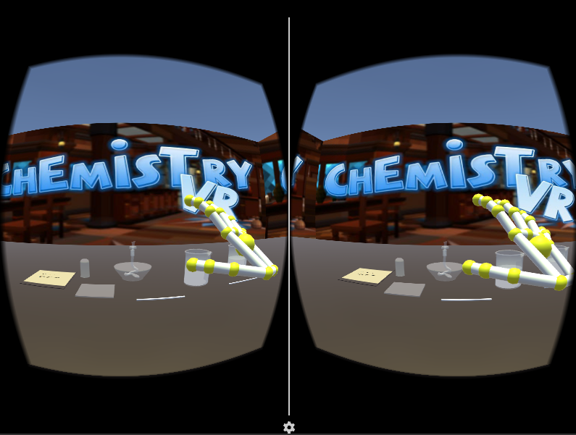

Figure 6-3. game scene

Experiment 1 ：Burning of magnesium strip

Before the experiment, it is necessary to perform the following operations: Since the magnesium strip has a layer of oxidized MgO on it, the melting point is very high and the magnesium strip is not visible. Therefore, the surface of the magnesium strip needs to be sanded before the experiment to remove the oxide film. The silvery white magnesium bar; the asbestos mesh on the lab table to prevent the product from splashing down after burning, and the asbestos web is also provided on the test bench in the scene. According to the two implementation methods used in this application, the operation steps are slightly different.

1，The experience1 process using Leap Motion + PC + Mobile

* Read the guidelines or videos on the desk (mark AR)
* Grab the match on the desk and Lighting alcohol lamp
* Use a pair of tweezers to clip one of the two magnesium strips on the table and burn one on the alcohol lamp
* Watch and record the phenomenon
* Put the burned magnesium strips in a beaker containing vinegar, Put the other(unburned) magnesium strips in a beaker containing vinegar
* See and record the phenomenon
* Extinguishing alcohol lamp

6.1.2 Oculus HMD

In the case of using the Oculus HMD and Controllers, it is divided into the Main scene and the ChemVR scene. In the Main scene, the main function is to select experiments and recognize the atomic structure model of the necessary elements in the periodic table, as shown in Fig. the middle of the scene. Periodic table of elements, the user can use the handle to control the cursor to select the experiment in the left menu bar, the corresponding experimental information and description will appear on the right display box, at the same time, the elements involved in the experiment will be highlighted, the user through the operator The handle on the handle can be pointed at the element to handle the element's atomic structure model with the handle pulled to the eye, as shown in Fig.



Figure 6-4. Main scene



Figure 6-5.

After you have finished observing the experiment information, select the experiment to be performed. Click the Go button to jump to the lab scene ChemVR under the ChemVR scene. The same UI layout, the left is the experimental information menu, click, the corresponding information appears in the middle panel. The user is in front of the experiment console, as shown in Fig. The user can refer to the displayed experimental procedure to start the experiment and observe the phenomenon.



Figure 6-6. ChemVR Scene



Figure 6-7. The Experiment desk

2，The experience1 process using Oculus HMD

* Choose the experience1 in main scene.
* Read the guidelines or videos on the desk
* Grab the match on the desk and Lighting alcohol lamp
* Use a pair of tweezers to clip one of the two magnesium strips on the table and burn one on the alcohol lamp
* Watch and record the phenomenon
* Put the burned magnesium strips in a beaker containing vinegar, Put the other(unburned) magnesium strips in a beaker containing vinegar
* See and record the phenomenon
* Extinguishing alcohol lamp

6.2 Implementation

When use Leap Motion as the interaction tool, users’ hand is recognized as the figure below.



Figure 6-8. Hand control with Leap Motion

Although Leap Motion currently does not support the direct link to the PC, the way to achieve Leap Motion and PC link is through the wireless network protocol linking the PC side as the server side, the mobile side as the client, running the program on the PC and the mobile phone at the same time, gesture recognition information passed The network protocol is transmitted to the PC for processing. Although this method realizes wireless connection and the mobile phone has certain mobility, it still cannot get rid of the PC. Therefore, the application is directly run in Unity, and the virtual mobile phone screen is used to implement virtualization. Real mode shows the game operation screen and the operation of leap Motion.

When use Oculus as the interaction tool. Oculus uses the Oculus as the interaction tool. Oculus controls the input by the handle, the left and right handles each have two buttons, a remote controller, a touch panel, and two trigger buttons. The left controller has a menu button, which is used to pause the game. In the game, the right controller has a main interface button, which is used to exit the game interface and return to the Oculus main interface. Each key corresponds to the following name.



Figure 6-9. Hand control with Leap Motion

6.2.1 Leap Motion + PC + Mobile

First, set up three scenarios and switch between scenes with the following code.

public class UIManager : MonoBehaviour {

public Button btn_Ar;

public Button btn_Vr;

// Use this for initialization

void Start () {

if (btn_Ar != null)

btn_Ar.onClick.AddListener(OnClickAr);

if (btn_Vr != null)

btn_Vr.onClick.AddListener(OnClickVr);

}

void OnClickAr()

{

SceneManager.LoadScene("ARPlayer");

}

void OnClickVr()

{

SceneManager.LoadScene("LeapVR");

}

}

LeapMotionMain.cs

private void SpawnManesiumRod()

{

if (magnesiumPrefab != null)

{

GameObject ma = Instantiate(magnesiumPrefab) as GameObject;

MagnesiumRod = ma;

MagnesiumRod.name = "MagnesiumRod";

MagnesiumRod.transform.localScale = Vector3.one;

MagnesiumRod.transform.localPosition = new Vector3(0.094f, 0.7f, 0.33f);

MagnesiumRod.transform.localRotation = Quaternion.Euler(Vector3.zero);

MagnesiumFire = MagnesiumRod.transform.Find("FlareMobile").gameObject;

InteractionManager.instance.RegisterInteractionBehaviour(MagnesiumRod.GetComponent<InteractionBehaviour>());

}

}

Download and install Leapmotion. I currently use the Leap Motion Unity package LeapMotion _CoreAssets _4.1.6.unitypackage, unity version 2017.1.1, using the latest Unity development kits need to use Unity version 5.5 or later, otherwise it will give an error. In our project, import the LeapMotion SDK. Next we can create a hand, find LeapMotion-Prefabs-LeapHandController to drag it to the scene (this is the hand controller), find LeapMotion-Prefabs-HandModelsNoHuman drag both CapsuleHand_L and CapsuleHand_R to the scene (this Is not with physical properties), then the hand with physical properties should be placed in the scene, there is a HandModelsPhysical folder under the HandModelsNoHuman file Drag RigidRoundHand_L and RigidRoundHand_R inside the scene, so that the hand is created In order to facilitate management, we create an object in the scene to manage the four hands we just created, create an empty object named HandModels in the scene, and use the hand we just dragged into the scene as its child. Object can be. As shown. You also need to set the LeapHandController, find it in the scene, and then in the Inspector panel, find the HandPool component, assign HandModels to ModelsParent, and find that ModelPool_size is set to 1. A hand with no physical attributes is assigned to the corresponding variable in Element0, and a hand with a physical attribute is assigned to the corresponding variable in Element1. This way we can configure our hands and run the program to test your hands.



Figure 6-10.

[Define some gesture](javascript:;)s that can interact with the object more accurate, such as lighting the alcohol lamp by pointing (with one index finger) the top of the alcohol lamp.

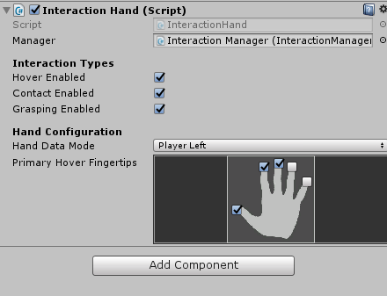 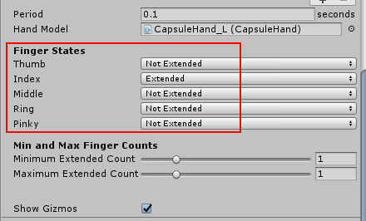

Figure 6-11. [Definition of hand gesture](javascript:;)s: Lighting the alcohol lamp by pointing with the index finger



Figure 6-12. Set fire

TriggertEnter () detects the contact between the magnesium bar and the alcohol lamp to burn.

private void TriggertEnter(GameObject arg1, Collider arg2)

{

if (arg2.transform.parent.tag == "GameObject")

{

//if (arg2.transform.parent.gameObject == LampShade)

//{

// lampshadeState = true;

//}

if (arg2.transform.parent.gameObject == MagnesiumRod)

{

if (MagnesiumState == false && MagnesiumIsFire == false && alcoholLampIsFire)

{

MagnesiumState = true;

this.ExecuteLater(() =>

{

if (MagnesiumIsFire == false && MagnesiumState == true)

{

MagnesiumFire.SetActive(true);

MagnesiumIsFire = true;

DOTween.To((float scaleX) =>

{

Debug.Log(scaleX);

//MagnesiumRod.transform.localScale = new Vector3(scaleX, MagnesiumRod.transform.localScale.y, MagnesiumRod.transform.localScale.z);

MagnesiumRod.transform.GetChild(0).GetComponent<MeshRenderer>().material.mainTextureOffset = new Vector2(1-scaleX / 2, 0.0f);//SetTextureOffset("_MainTex",new Vector2(scaleX/2, 0.0f));

}, MagnesiumRod.transform.localScale.x, 0, 10).OnComplete(() =>

{

MagnesiumIsFire = false;

InteractionManager.instance.UnregisterInteractionBehaviour(MagnesiumRod.GetComponent<InteractionBehaviour>());

//Destroy(MagnesiumRod);

//SpawnManesiumRod();

MagnesiumFire.SetActive(false);

});

}

MagnesiumState = false;

}, 1.0f);

}

}

}

}

Experiment process screen:



Figure 6-13.

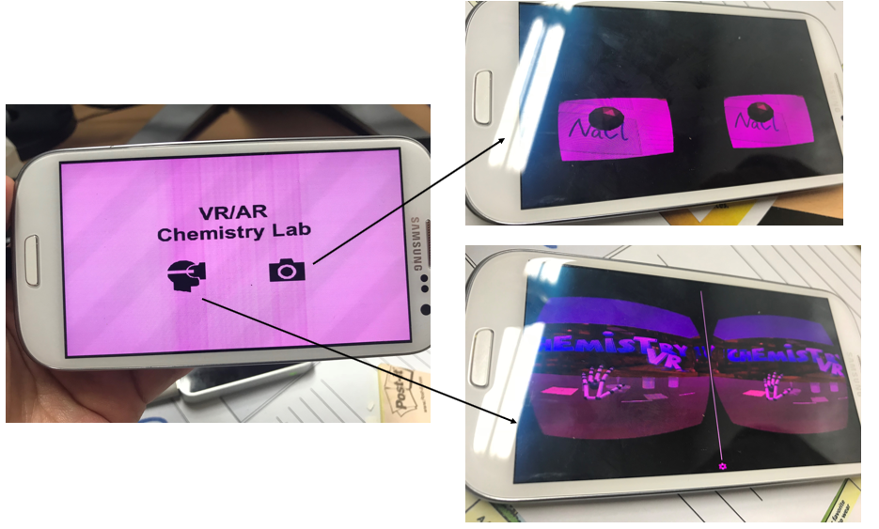

Figure 6-14. main game

6.2.2 Oculus + PC

Download the corresponding components on the Oculus Developer Center website, Oculus Utilities for Unity, Unity 4 Legacy Integration, Oculus Avatar SDK, and Oculus Platform SDK to import these four components into Unity and find the OVRCameraRig prefabs to drag into the hierarchy view.

6.3 Conclusion

Ⅶ Evaluation

Educational games are games that have game features and educational functions. They are essentially computer games created by game designer and carry educational and entertainment purposes. Educational game evaluation is the important process of design and development. It plays a certain guiding role. Evaluating educational games in an effective manner is a powerful guarantee for the development of educational games. For developers, there is a standard that can be used for reference, can help the developer not only develop targeted educational games but also save time and costs. For teachers and students, they can quickly find a right game that assists teaching and mobilizes students' interest in learning. For parents and schools, it can effectively eliminate the traditional prejudice of the game and establish a scientific education attitude. Warren Buckleitner, a child and technologist in the United States, believes that gamified learning software is three-dimensional, in addition to evaluating the quantity (number of tasks) and quality (story, animation). The evaluation also has to include the children’s experiencefeeling of the controller and the UI design , etc. in the use of software, The evaluation of the software experience feeling is like evaluating teacher-student interaction. Warren Buckleitner's point of view actually coincides with the constructivist learning theory. Constructivism emphasizes the role of meaning construction and social-cultural interaction in learning, emphasis on the situational of learning knowledge and wisdom. Situations synthesize knowledge through activities, so that learning should happen in a similar situation to the actual situation. Virtual Reality and Augmented Reality educational games can provide learners with a real and open situation. Students can actively explore and solve various problems.

The goal of educational game evaluation is to judge its role as a learning tool for the promotion of learning, that is, to fully exploit the educational value of educational games. Alvaro, the chief research institute of non-profit education research and development organizations in the US, and Babette, a researcher of the Center for Children and Family Studies, combed the game-based learning environment. The evaluation literature provides a gradual process for evaluating the digital gaming learning environment, including the following five steps:

Table 7-1: Five Steps for Digital Gamification Learning Environment Evaluation [33]

|  |  |
| --- | --- |
| Steps | Specific description |
| Step 1 | Get the software by purchasing or getting the demo and account and get the evaluation permission |
| Step 2 | Satisfy the running hardware conditions of the software, clarify the purpose of education, target users, and the completed non-gaming learning environment that can help achieve learning objectives |
| Step 3 | Analyze how other organizations evaluate the software and can be used as a reference |
| Step 4 | Target users try out the software and conduct surveys and interviews with them after the end of the experience |
| Step 5 | Use evaluation gauges for further analysis |

It can be seen that the evaluation mainly used the comparative method, the questionnaire survey method, the interview survey method, and the gauge measurement.

The evaluation of educational games by the 80days digital educational game project team is not limited to games that have already been developed and put into use. They track and evaluate educational games from design and development to application, and formative and summative evaluations are combined together. First, a questionnaire survey on game design concept prototypes is used to obtain children's acceptance of the game design; Then expert review on game usability and playability is carried out when the game development is successful and can be run, exclude various issues in game design and development; Then select a school in the United Kingdom and Australia as a user group for testing, including usability, user experience, and teaching effectiveness. Finally, draw questions from the conclusions and conduct focus group interviews. [34] The questionnaire survey method, expert review method, experiment method (pre-test and post-test of user's learning content) and interview survey method were used in the evaluation process, and the quantitative evaluation method was combined with the qualitative evaluation method.

7.1 Educational Game Evaluation Gauge

Evaluation gauge is a tool for authenticity evaluation. It is composed of a series of indicators. It is a set of criteria for evaluating or registering the characteristics of educational games. It is also an important bridge that connected between the development, the application and the evaluation of educational games. The use of gauges to evaluate educational games actually belongs to the indicator quantitative evaluation method, evaluating educational games using evaluation scales is simple and easy. It has changed the general and ambiguous evaluation content of some educational game evaluation methods. It decomposes the evaluation content into specific processes and has a good operability and short duration. In the following table7-2, evaluation gauges used by teachers' parents or game developers and designers.

Table 7-2. Educational Game Evaluation Gauge Study

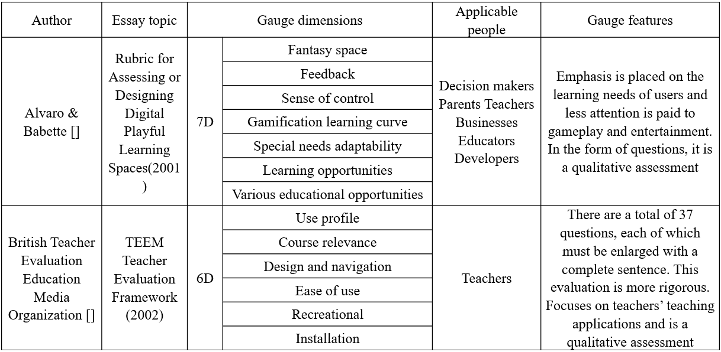

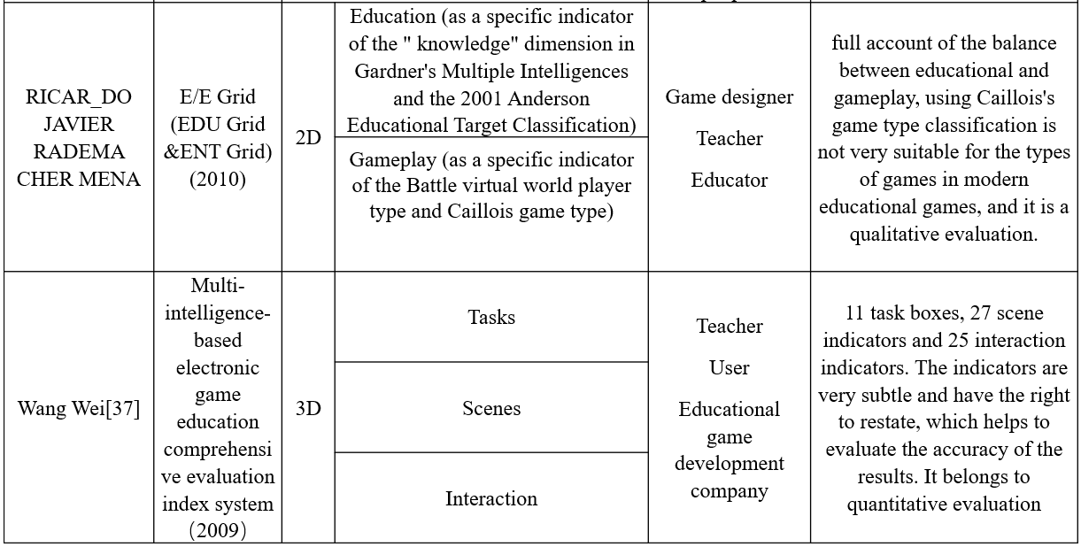

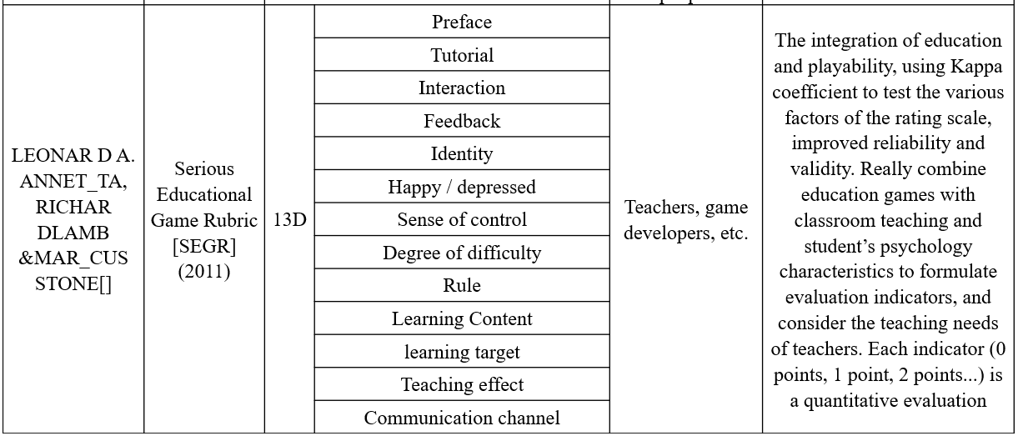

7.2 Evaluate system

According to the evaluation, the performance, cost, and portability of the device, as well as the user's experience, educational effectiveness, etc., are performed. Among them, the cost performance and portability are inherent attribute characteristics of the device itself. The user experience and the educational effect need to be verified through testing. The experience sense and the educational effect are interviewed through oral questions. Combined with the characteristics of each evaluation system summarized in the previous section, and the characteristics of virtual reality educational games, the following table is based on the evaluation system:

Table 7-3. Educational purposes and target audience for each game in this application

|  |  |  |
| --- | --- | --- |
| Game | target | Educational goals (effects) |
| AR 3D Coloring Game | 6 year;  Pre-school | Develop children's color recognition and hands-on skills. |
| VR Art Exhibition | 20 year; college | Watching works of art |
| MR Chemistry Lab | 20 year; college | Get rid of the time and space limitations of doing chemical experiments |

The innovative Wang Wei (2010) researched a multiple-intelligence-based electronic game evaluation scale. Based on the influence of video games on the multiple intelligence of young people, electronic games were divided into language-based and music-based, etc. eight types, and give each type an evaluation gauge and assign weights to it. At present, there are many types of educational games. They all have their own distinct characteristics. It is difficult to align these features with the same gauge to make a correct evaluation. Only the same type of games is comparable. The three models in this study all belong to virtual reality, augmented reality educational games. One of the hallmarks of these games is immersion so that need to experience immersions and senses of control. The main theoretical analysis is qualitative analysis, which confirms the lack of quantitative analysis. Based on the above introduction and the features of virtual reality, augmented reality programs and two types of target populations, this paper has designed the following evaluation gauge, table7-4. Besides, of the three applications in this study, the 3D coloring game is for preschool children, and the Chemistry lab and art exhibition are for high school students. Therefore, the evaluation system is divided into two categories. The first category is the children's group, and the second is the adult group.

Table 7-4: The appraisal system's gauge dimension design in this study

|  |  |  |
| --- | --- | --- |
| Gauge dimensions | Evaluation method | |
| The first category | The second category |
| hardware equipment | record | record |
| Immersive | Interview | Interview |
| Educational effect | Interview | Questionnaire |
| Interaction and Sense of control | Interview | Interview |
| Degree of difficulty | Interview | Questionnaire |

However, just using evaluation scales to judge the application value of educational games is not comprehensive enough, and the evaluator still needs to examine the changes in learning behaviors and learning results after learners use educational games in order to make in-depth, comprehensive and reasonable evaluations.

7.3 Evaluations for the 3 cases

In the previous section, we introduced that we divided the three games into two categories for evaluation. The four applications were targeted at different ages. The AR 3D coloring games targeted preschool children. The average age is 6 years old, including 5 in the experimental group and 5 in the comparison group. The selected children were familiar with the basic operation of the mobile phone, while the VR art Exhibition and the VR Chemistry Lab focused on the subject of extended education and the choice of subjects. There are 10 undergraduates in art and science. There are no gender restrictions. The test tasks are divided into four groups. Each game has an experimental group and a comparison group. The subjects of the experimental group implement the projects developed in this thesis and compare the group's object experience with the traditional group games with the same function as the experimental group. As shown in the table below.

Table 7-5. Number of subjects and grouping

|  |  |  |  |  |  |  |  |  |  |  |  |
| --- | --- | --- | --- | --- | --- | --- | --- | --- | --- | --- | --- |
| Game | AR 3D coloring game | | | VR art Exhibition | | | MR Chemistry Lab | | | | |
| AR | Non- AR | Normal | VR | Non- VR | Normal | MR | Non- MR | Normal |
| Number | 5 | 5 | 5 | 5 | 5 | 5 | 5 | 5 | 5 |
| Total | 15 | | | 15 | | | 15 | | | |

7.3.1 The first category

This evaluation is aimed at the game 3D coloring game. This is a puzzle virtual reality augmented reality game developed for preschool children. The participants of this category include game developers and game target audiences (Preschool children). The results are as follows:

Table 7-6 ：The first category evaluation result

|  |  |  |  |
| --- | --- | --- | --- |
| Gauge dimensions | Evaluation method | Evaluation result | |
| Experimentalgroup | Control group |
| hardware equipment | record | Requirements for the game: Android phone, printed identification map  Required hardware is readily available and portable |  |
| Educational effect | Interview | The subject has a preliminary understanding of the globe |  |
| Interaction & Sense of control | Interview | Simple operation: click  Can achieve precise control |  |
| Degree of difficulty | Interview | Simple |  |

7.3.2 The second category

This review includes VR Art Exhibition and MR Chemistry Lab. These are two types of virtual reality augmented reality games developed for college students. Participants in this category include game developers (game development practitioners) and game target audiences (college students). The results are as follows:

Table 7-7. The second category VR Art Exhibition evaluation result

|  |  |  |  |
| --- | --- | --- | --- |
| Gauge dimensions | Evaluation method | Evaluation result | |
| Experimentalgroup | Control group |
| Hardware equipment | Record | Oculus HMD, Hand Controllers,  Expensive, poor mobility |  |
| Immersive | Interview | Strong |  |
| Educational effect | Questionnaire | Good |  |
| Interaction & Sense of control | Interview | Interaction is not nature but accuracy, feel dizziness when worn for a long time |  |
| Degree of difficulty | Questionnaire | Biased difficult |  |

Table 7-8. The second category MR Chemistry Lab evaluation result

|  |  |  |  |
| --- | --- | --- | --- |
| Gauge dimensions | Evaluation method | Evaluation result | |
| Experimentalgroup | Control group |
| Hardware equipment | Record | Oculus HMD, Hand Controllers,  Expensive, poor mobility |  |
| Immersive | Interview | Immersion is stronger and can be enhanced by the design of the laboratory art is more like a real laboratory |  |
| Educational effect | Questionnaire | Learned and repeatedly practiced the basic process of chemical experiments  Observed experimental phenomena |  |
| Interaction & Sense of control | Interview | Good interaction accuracy, but dizziness when worn for a long time |  |
| Degree of difficulty | Questionnaire | Biased difficult |  |

Ⅷ Conclusions

This chapter reviews the achievements of the research objectives. Then, the conclusions and contributions of the research are discussed. Finally, some possibilities of future researches are outlined.

“The pedagogy of constructive learning and game-based learning tells us that children learn best when they are hands-on experience,” says Corbett. Ability to introduce experimental knowledge without leaving the classroom, which gives the educational experience an unparalleled value. Students are no longer attending lectures but follow annotations in the headset to get a real experience. Inge Knudsen, a virtual reality education expert, has set up a virtual construction site with many safety issues. Students can walk around in a virtual environment and find insecure places to take pictures. Such cases cannot be performed in real life. Therefore, they are particularly suitable for virtual worlds. The immersive virtual scene allows students to learn and experience any area of ​​work and daily life. The defects and limitations in education in reality are solved and improved by using mixed reality technology, which makes the education process vivid and exciting, and some of the scenarios and effects that are not possible under the traditional education model become possible in the virtual world. In addition, virtual reality arises the probability of participation will eventually shift the students' desire to explore from the beginning of play to learning and thinking.

“Motivation and participation are the key factors for game-based learning, and virtual reality takes these two factors to new heights,” said Corbett, managing director of MissionV. What is the fundamental purpose of education? He is the key to self-knowledge, a tool for obtaining work, and an experience, preferably a positive, attractive experience. After all, people have to spend many years in education.

Through the analysis of the experimental results of this study

Appendix I: Virtual & Augmented Education Scenarios

Appendix II: Questionnaire for Subjective Evaluation

Appendix III: Paper Based Examination

Appendix IV: Comparison of use of VR and AR system with traditional whiteboard based lecture

# **References**

1. AR, http://whatis.techtarget.com/definition/augmented-reality-AR, [Article(CrossRef Link)](http://whatis.techtarget.com/definition/augmented-reality-AR)

——http://www.baike.com/wiki/ugc?hf=youdaocitiao&pf=youdaocitiao

1. <http://vr.99.com/news/07192017/001616650.shtml>
2. 作者：胡痴儿2.0。链接：https://www.zhihu.com/question/36979454/answer/95047656
3. 作者：犬一。链接：https://www.zhihu.com/question/36979454/answer/125991422
4. 作者：世界两侧。链接：<https://www.zhihu.com/question/36979454/answer/90834848>
5. 作者：陈儿.链接：<https://www.zhihu.com/question/36979454/answer/191543111>
6. <https://www.quora.com/What-is-the-difference-between-augmented-reality-and-mediated-reality-1>
7. <http://jp.trane.com/commercial/global/latin-america/es/markets/k-12-education.html>
8. <https://zhuanlan.zhihu.com/p/22135486>
9. The Virtual Lab (Physics & Chemistry) for Malaysia’s Secondary School [accessed Oct 3, 2017].
10. Augmented Reality: What Does It Mean for UX?
11. <http://www.weihk.cn/article/237816>
12. Google Translate review: how well does the new app work?
13. WU H K,LEE S W Y,CHANG H Y,et al.Current Sta-tus,Opportunities and Challenges of Augmented Reality in Education[J].Computers & Education(S0360-1315),2013,62(3)： 41-49.
14. The Economics.The Promise of Augmented Reality[DB/OL]. (2017-02-04)[2017-02-28].http://www.economist.com/news/ science-and-technology/21716013-replacing-real-world-virtual-one-neat-trick-combining-two.
15. NUNEZ M,QUIROS R,NUNEZ I,et al.Collaborative Aug-mented Reality for Inorganic Chemistry Education In 5th WSEAS/IASME International Conference on Engincering Education,Heraklion,Greece,July 22-24,2008.
16. GOLDMAN SACHS.Virtual & Augmented Reality Under-standing the Race for the Next Computing Platform[DB/OL]. (2016-03-09)[2017-02-20].http://www.goldmansachs.com/ our-thinking/pages/virtual-and-augmented-reality-report.html.
17. WATSON J B.Psychology as the Behaviorist Views It[J].Psy-chological Review(S0033-295X),1913,20(2)：158.
18. PIAGET J.The Stages of the Intellectual Development of the Child.Educational Psychology in Context:Readings for Future Teachers [M].1965.
19. JONASSEN D H.Thinking Technology:Toward a Construct-ivist Design Model[J].Educational Technology(S0013-1962), 1994,34(4)：34-37.
20. 蔡苏, 王沛文, 杨阳, 等. 增强现实(AR) 技术的教育应用综述 [J]. 远程教育杂志,2016,(5)：27-40.
21. RYFFEL M,MAGNENAT S.Augmented Creativity: Bridging the Real and Virtual Worlds to Enhance Creative Play[C].Proceedings of the SIGGRAPH Asia 2015 Mobile Graphics and Interactive Applications,Kobe:ACM，2015：1-12.
22. HORNECKER E,DUNSER A.Of Pages and Paddles: Children’s Expectations and Mistaken Interactions with Physical-digital Tools [J].Interacting with Computers (S0953-5438),2009,21(1)：95-107.
23. Virtual &Augmented Reality The Goldman Schs Group,Inc. Jan 13,2016.
24. <https://zhuanlan.zhihu.com/p/32865565>
25. Human interface guidelines <https://developer.apple.com/ios/human-interface-guidelines/technologies/augmented-reality/>
26. Thomas Caudell and David Mizell Augmented reality: An application of heads-up display technology to manual manufacturing processes
27. 王丹，段渭军，李星，SOOLDE在工科院校实验合成中应用初探，现代教育技术Modern Educational Technology， Vol.20, No, 12, 2010
28. <http://www.shafa.com/articles/zIHzY7BRArZmpcYY.html>
29. <https://t.qianzhan.com/kuaixun/detail/161118-3fa346e7.html>
30. iPhone X’s Emoji Innovation Tracks Your Face
31. AR, http://whatis.techtarget.com/definition/augmented-reality-AR, [Article(CrossRef Link)](http://whatis.techtarget.com/definition/augmented-reality-AR)